Multi Robot Coordination For Swarm Robotics

Swarm robots use a coordinated shared intelligence to operate as a group and work in coordination. These applications require the use of wireless communication for fast and efficient communications. Our system uses this concept to apply it in a pair of swarm robots that are based on a master slave relationship. The master robot is integrated with IR sensors to perform a specific task. In this case the master has a circuitry that consists of an integrated IR sensing circuit controller by a microcontroller circuit that is used to follow a line. The IR sensors are used to sense the line drawn and follow using reflected light principle of operation. While performing its operation the controller also transmits the movement commands to the slave robot using Rf communication. The slave robot consists of an microcontroller circuit integrated with similar motorized robotic body as the master. It receives the commands sent by master and operates the motors in order to achieve motion as per commands sent by the master. Thus we successfully achieve a master slave communication through the use of swarm robotics concepts.

Block Diagram :
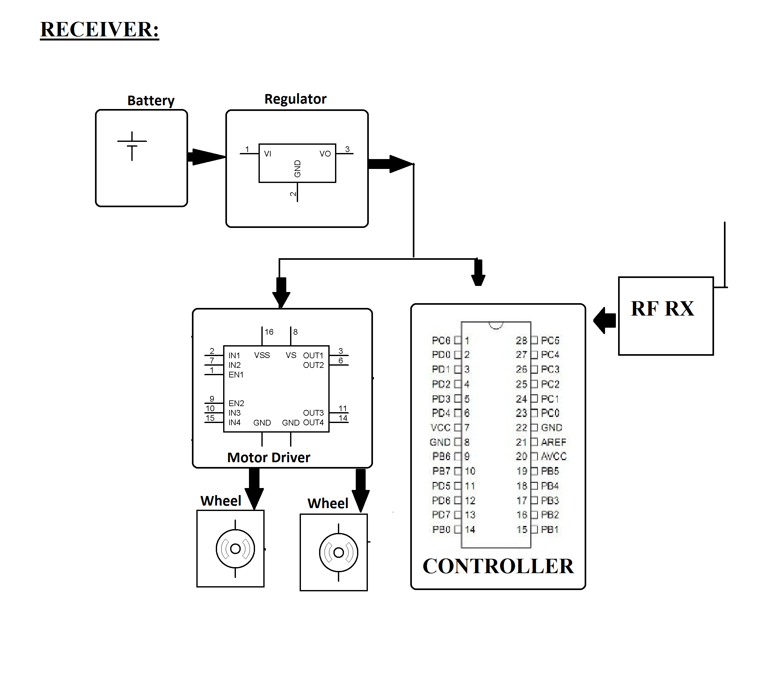
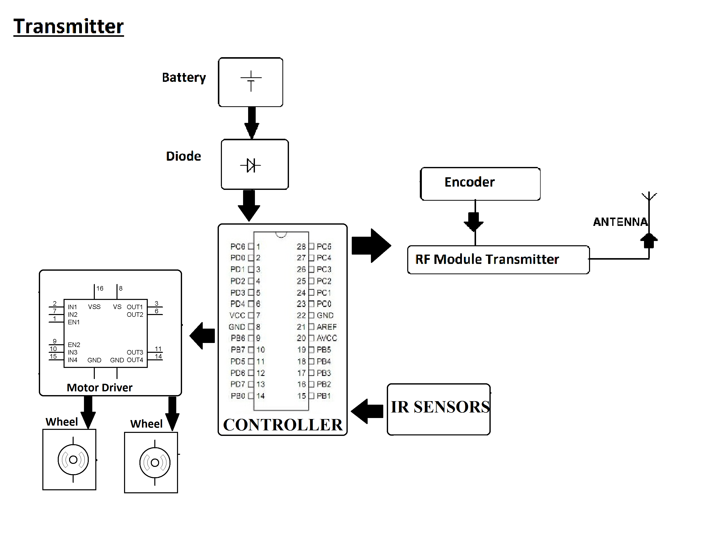

Hardware Specifications
- 2 x Robot Body
- DC Motors
- PIC Microcontrollers
- RF Transmitter
- RF Receiver
- Resistors
- Capacitors
- Diodes
- LED’s
- Coil Antennas

Software Specifications
- MPLAB
- MC Programming Language: C

